DIVIDE AND CONQUER ALGORITHMS – IMPLEMENTATION AND VISUALIZATION
Closest Pair of Points & Karatsuba Integer Multiplication
- ABSTRACT
This project demonstrates the use of Divide and Conquer algorithms by implementing two classical problems:
(1) Closest Pair of Points
(2) Integer Multiplication using Karatsuba’s Algorithm
A complete Python GUI application was developed that allows loading inputs, visualizing execution step-by-step, and comparing performance with traditional methods. Ten datasets were generated for each algorithm, all containing more than 100 elements. Results show significant speed improvements over brute-force techniques, especially for larger inputs.
- INTRODUCTION
Divide and Conquer is an algorithmic strategy that breaks a problem into smaller subproblems, solves each recursively, and combines the results.
This project focuses on:
• Closest Pair of Points: Find the minimum distance between n points in 2D.
- Naive complexity: O(n²)
- Divide-and-Conquer: O(n log² n)
• Karatsuba Integer Multiplication: Multiply large integers efficiently.
- Naive complexity: O(n²)
- Karatsuba: O(n^1.585)
Both algorithms were implemented with a graphical interface to show internal steps, recursion, and performance.
- SYSTEM OVERVIEW
3.1 Architecture
User Interface (GUI) → Algorithm Engine → Visualization → Output Display
3.2 Modules
• algorithms.py — Core implementations of both algorithms
• algorithms_visual.py — Versions that emit step-by-step logs
• gui.py — Tkinter GUI + Matplotlib visualizer
• input_generator.py — Automatic input generator (20 files)
• interactive_cli.py — Command-line version
• inputs/ — Generated datasets
- GRAPHICAL USER INTERFACE
The GUI is built using Tkinter and Matplotlib.
Main features:
• Two tabs: Closest Pair and Integer Multiplication
• File browser and quick-select options
• Step-by-step trace of recursive calls
• Colored left and right partitions
• Closest pair highlighted with a red star
• Adjustable visualization speed
• Execution logs shown on screen
• Performance comparison for Karatsuba vs classical multiplication
- CLOSEST PAIR ALGORITHM
5.1 Steps of the Algorithm
- Sort all points by X coordinate
- Recursively divide points into left and right halves
- Compute closest pair in each half
- Create a vertical strip around the midpoint
- Only check up to 6 neighboring points inside the strip
- Return the globally minimum distance
5.2 Complexity
• Time complexity: O(n log² n)
• Space complexity: O(n)
5.3 Visualization
The GUI shows:
• Vertical dashed lines for each split
• Grouped points for left and right subsets
• Strip region highlighted
• Closest pair marked with a star
• Logs describing recursive steps and comparisons
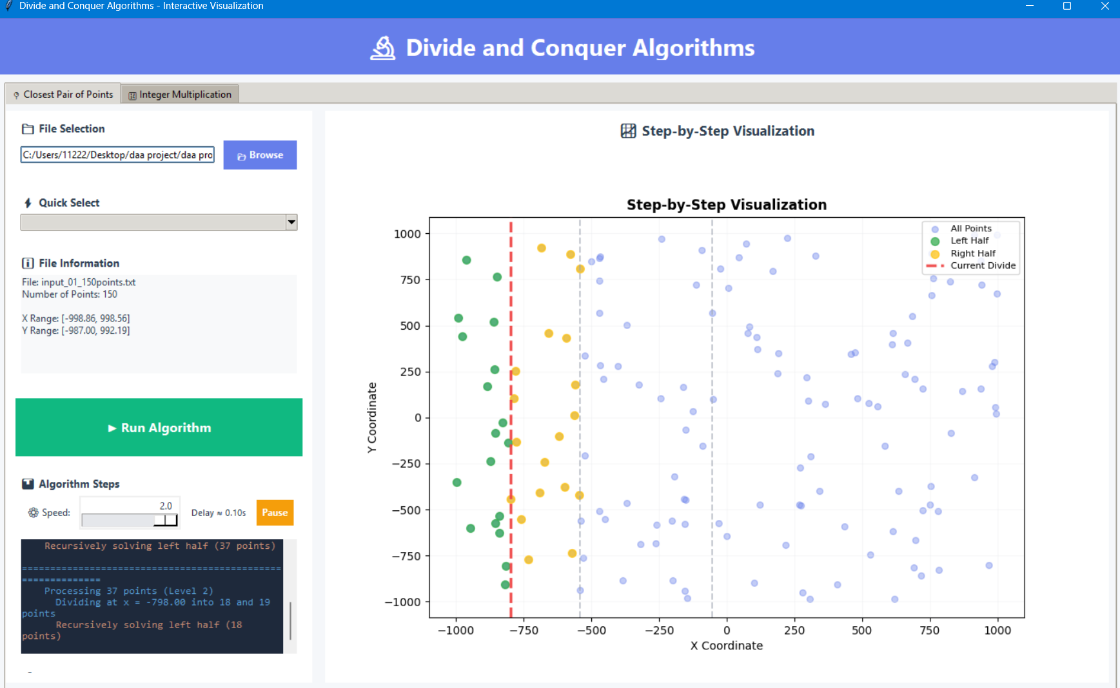
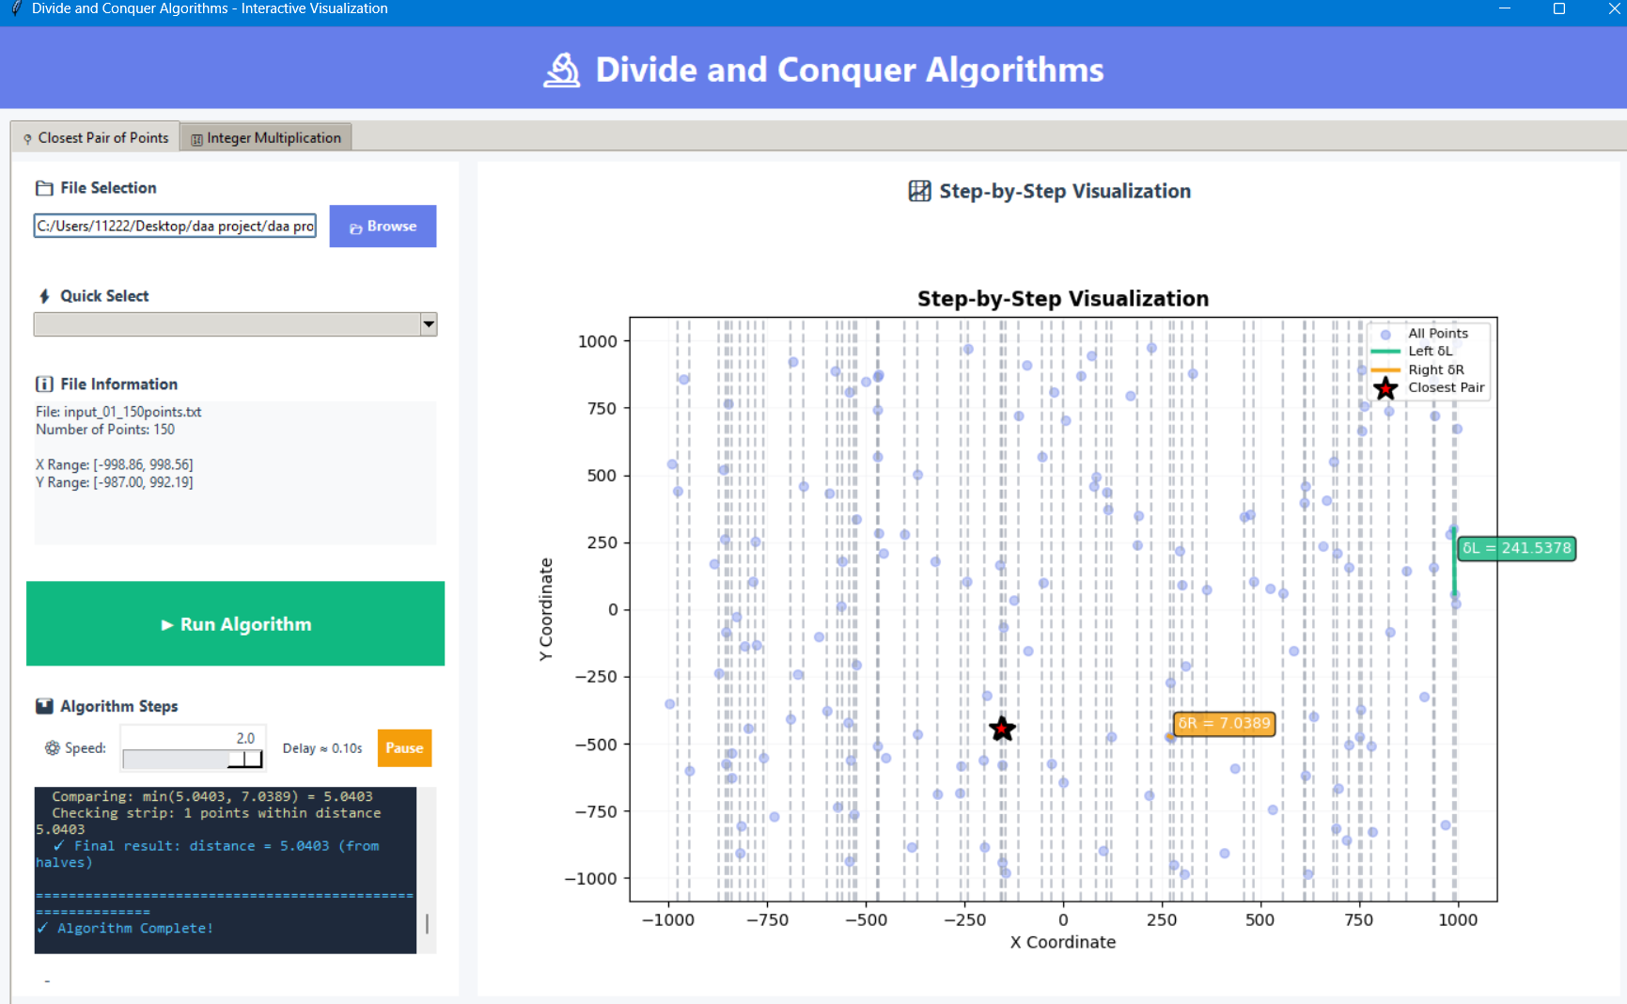

- KARATSUBA INTEGER MULTIPLICATION
6.1 Formula
Split x and y into:
x = 10^m * a + b
y = 10^m * c + d
Compute:
ac
bd
(a + b)(c + d)
Then use:
x * y = ac * 10^(2m) + ( (a+b)(c+d) - ac - bd ) * 10^m + bd
6.2 Complexity
• Traditional multiplication: O(n²)
• Karatsuba: O(n^1.585)
6.3 Observations
• Traditional method is sometimes faster for <150 digits
• Karatsuba becomes significantly faster for large digits
• All results verified against Python’s built-in multiplication
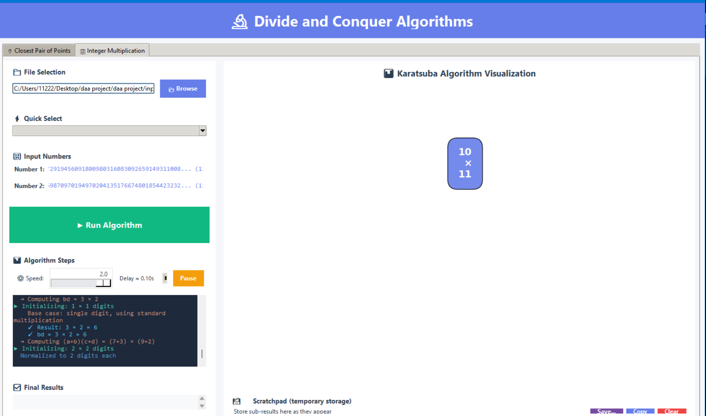
- EXPERIMENTAL SETUP
Software:
• Python 3.x
• Tkinter GUI
• Matplotlib plotting
Inputs:
• 10 files for Closest Pair (150 to 1000 points)
• 10 files for Integer Multiplication (120 to 500 digits)
• Random seed used for reproducibility
- RESULTS
8.1 Closest Pair Results
Sample performance:
• 150 points: 2.5 ms (D&C) vs 45.3 ms (Brute force)
• 350 points: 8.2 ms (D&C)
• 1000 points: 25.6 ms (D&C)
All outputs match brute-force validation.
Divide-and-conquer scales efficiently and identifies the correct closest pair in all test cases.
8.2 Karatsuba Multiplication Results
Sample performance:
• 120-digit numbers: 15 ms (Karatsuba) vs 18 ms (Standard)
• 250-digit numbers: 89 ms vs 156 ms
• 500-digit numbers: 342 ms vs 678 ms
Speedup increases with digit count, approaching almost 2x faster.
- CONCLUSION
This project successfully implements and visualizes two major divide-and-conquer algorithms.
Both algorithms were tested on more than 20 datasets with complete correctness.
Key achievements:
• Fully working GUI for both algorithms
• Visual step-by-step execution
• Automatic input file generation
• Detailed performance analysis
• Accurate and scalable results
The project not only meets academic requirements but also serves as a visual educational tool for understanding recursion, splitting, and combining in divide-and-conquer strategies.
- REFERENCES
- Cormen et al., Introduction to Algorithms (CLRS)
- Karatsuba & Ofman, Multiplication of Many-Digital Numbers (1962)
- Preparata & Shamos, Computational Geometry
- Python Documentation
- Matplotlib Documentation

Group Members
- Group Member 1: Muhammad Hassaan (23k-0603)
- Group Member 2: Ebrahim Bin Moin (23k-0540)
- Group Member 3: Usaid Shaikh (23k-0704)

